Name:k.vigneshwaran

Reg no: 210521205056

# **Introduction**

“The purpose of ‘My Travel Adventures’ is to inspire, inform, and connect travel enthusiasts from around the world. Our blog is dedicated to providing valuable insights into travel destinations, culture, and exploration. We aim to offer practical tips and recommendations to make your travels more enjoyable and enriching. Whether you’re seeking advice on planning your next trip, cultural insights, or simply a dose of wanderlust, our blog is your go-to resource. We believe that travel has the power to broaden horizons, foster understanding, and create lasting memories. ‘My Travel Adventures’ is here to fuel your passion for travel and help you embark on journeys that will leave a lasting .

Structure of website:

### 1. Header:

- Blog Name and Logo

- Navigation Menu (Home, Destinations, Blog, Contact)

### 2. Home Page:

- Welcome Message

- Featured Blog Posts

### 3. Destinations:

- List of Featured Destinations

- Links to Individual Destination Pages

### 4. Blog Posts:

- Individual Blog Post Pages

- Categories or Tags for Posts

- Comment Section for Reader Interaction

5. Contact Page:

- Contact Form

- Contact Information (Email, Social Media Links)

6. Footer:

- Copyright Information

- Links to Privacy Policy, Terms of Use, etc.

7. Social Sharing and Follow Buttons:

- Encourage readers to share your content and follow your social media profiles.

8. Subscribe Option:

- Allow readers to subscribe to your blog for updates.

# **Design Layout with HTML and CSS**:

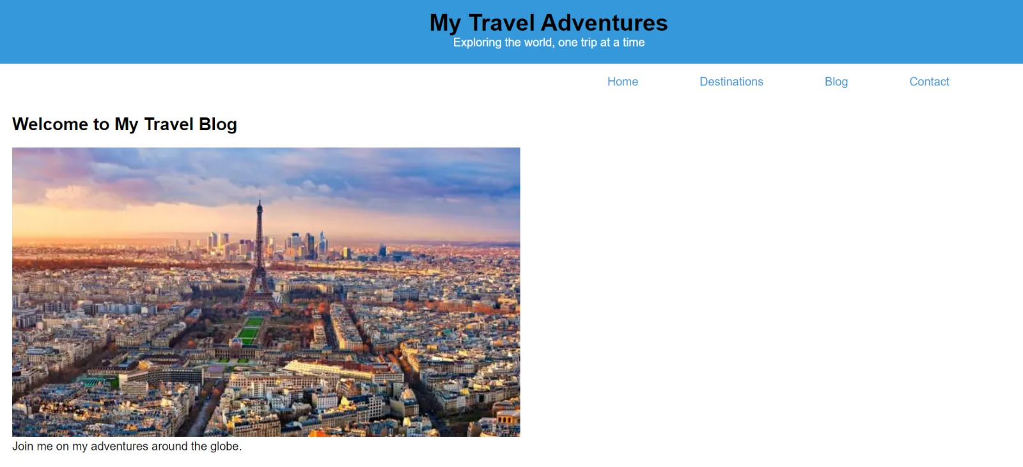

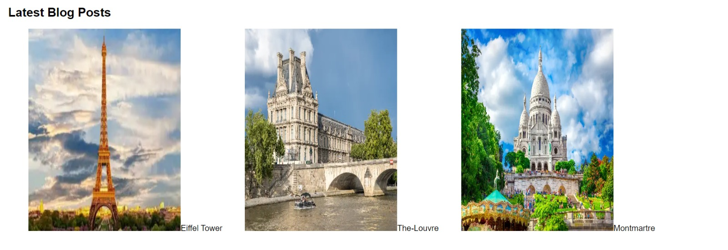

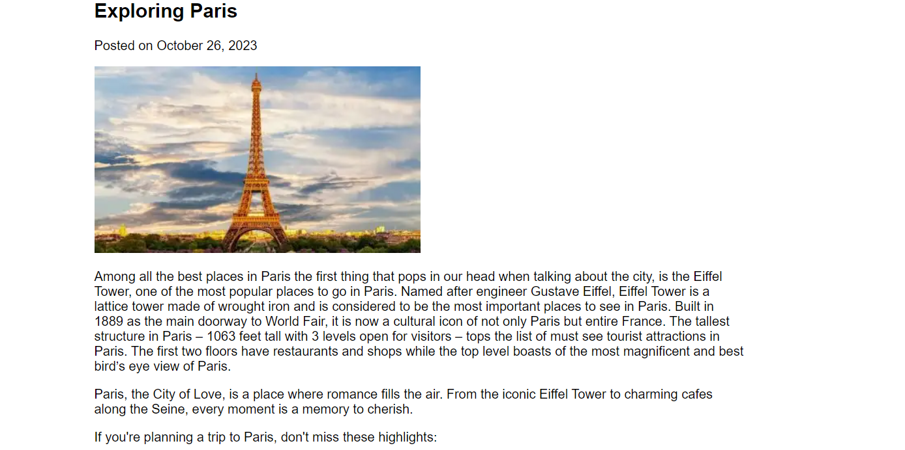

**Program codes :**

**Index.html**

<!DOCTYPE html>

<html>

<head>

    <title>My Travel Blog</title>

    <link rel="stylesheet" type="text/css" href="style.css">

    <link rel="stylesheet" href="https://cdnjs.cloudflare.com/ajax/libs/font-awesome/6.4.2/css/all.min.css" integrity="sha512-z3gLpd7yknf1YoNbCzqRKc4qyor8gaKU1qmn+CShxbuBusANI9QpRohGBreCFkKxLhei6S9CQXFEbbKuqLg0DA==" crossorigin="anonymous" referrerpolicy="no-referrer" />

</head>

<body>

    <header>

        <h1>My Travel Adventures</h1>

        <p>Exploring the world, one trip at a time</p>

    </header>

    <nav>

        <ul>

            <li><a href="#home">Home</a></li>

            <li><a href="destination.html">Destinations</a></li>

            <li><a href="blogpost.html">Blog</a></li>

            <li><a href="contact.html">Contact</a></li>

        </ul>

    </nav>

    <section id="home">

        <h2 id="welcome">Welcome to My Travel Blog</h2><br>

        <img src="paris.webp">

        <p>Join me on my adventures around the globe.</p>

    </section>

    <section id="destinations">

        <h2>Featured Destinations</h2><br>

        <!-- Add images and descriptions of your favorite destinations -->

        <p>Paris is positioned at the centre of the Île-de-France region, which is crossed by the Seine, Oise, and Marne rivers. The city is ringed with great forests of beech and oak; they are called the “lungs of Paris,” for they help to purify the air in the heavily industrialized region.</p>

    </section>

    <section id="blog">

        <h2>Latest Blog Posts</h2><br>

        <!-- Create blog post entries with titles, content, and images -->

        <img src="eiffel.webp" alt="" width="300px" height="400px" id="image"><caption>Eiffel Tower</caption>

        <img src="The-Louvre..webp" alt="" width="300px" height="400px" id="image"><caption>The-Louvre</caption>

        <img src="image1.webp" alt="" width="300px" height="400px" id="image"><caption>Montmartre</caption>

    </section>

    <section id="contact">

        <h2>Contact Me</h2><br>

        <p>Feel free to reach out if you have any questions or want to share your travel stories.</p><br><br>

        <i class="fa-brands fa-instagram fa-bounce fa-lg" style="color: #d31785; font-size:35px;"></i>

    </section>

    <div id="foot">

        <footer>

            <p>&copy; 2023 My Travel Blog</p>

        </footer>

    </div>

</body>

</html>

**Style.css**

body, h1, h2, p {

    margin: 0;

    padding: 0;

}

h1{

    text-align: center;

    color: black;

}

#welcome{

    color: black;

}

body {

    font-family: Arial, sans-serif;

}

header {

    background-color: #3498db;

    color: white;

    text-align: center;

    padding: 20px;

}

nav ul {

    list-style-type: none;

    margin-left: 800px;

}

nav ul li {

    display: inline;

    margin-right: 80px;

}

nav a {

    text-decoration: none;

    color: #3498db;

}

section {

    padding: 20px;

}

footer {

    background-color: #3498db;

    color: white;

    text-align: center;

    padding: 10px;

}

#image{

    margin-left: 40px;

}

**Blogpost.html**

<!DOCTYPE html>

<html>

<head>

    <title>My Travel Blog - Exploring Paris</title>

    <link rel="stylesheet" type="text/css" href="blogpost.css">

</head>

<body>

    <header>

        <h1>My Travel Blog</h1>

        <p>Exploring the world, one trip at a time</p>

    </header>

    <article class="blog-post">

        <h2>Exploring Paris</h2>

        <p>Posted on October 26, 2023</p>

        <img src="eiffel.webp" alt="Eiffel Tower in Paris">

        <p>Among all the best places in Paris the first thing that pops in our head when talking about the city, is the Eiffel Tower, one of the most popular places to go in Paris. Named after engineer Gustave Eiffel, Eiffel Tower is a lattice tower made of wrought iron and is considered to be the most important places to see in Paris. Built in 1889 as the main doorway to World Fair, it is now a cultural icon of not only Paris but entire France. The tallest structure in Paris – 1063 feet tall with 3 levels open for visitors – tops the list of must see tourist attractions in Paris. The first two floors have restaurants and shops while the top level boasts of the most magnificent and best bird’s eye view of Paris.</p>

        <p>Paris, the City of Love, is a place where romance fills the air. From the iconic Eiffel Tower to charming cafes along the Seine, every moment is a memory to cherish.</p>

        <p>If you're planning a trip to Paris, don't miss these highlights:</p>

        <ul>

            <li>Visit the Eiffel Tower for breathtaking views of the city.</li>

            <li>Stroll through Montmartre and explore the charming streets of this artistic neighborhood.</li>

            <li>Indulge in croissants and coffee at a local café and people-watch.</li>

        </ul>

        <p><b>Don’t miss:</b> A fabulous view of Paris from the transparent new first floor and second floor, Eiffel Tower Shops for souvenirs, and exotic dine and wine at Le 58 tour Eiffel and Le Jules Verne<br><br>

            <b>Opening hours:</b> Mid June to early September: 9 am to 12 midnight and Rest of the year: 9:30 am to 11:30 pm<br><br>

            <b>Entry fee:</b> Entry Fee to Eiffel tower for kids below 4 years is free. Rest of rates are as follows:

            Lift Entrance upto 2nd Floor – INR 861 (€11,00) for adults, €8,50 for children (12-24) years, €4,00 for children ( 4-11) years, differently abled and French job seekers<br>

            Lift Entrance upto Top Floor – €17,00 for adults, €14,50 for children (12-24) years, €8,00 for children ( 4-11) years, differently abled and French job seekers<br>

            Stair Entrance upto 2nd Floor – €7,00 for adults, €50 for children (12-24) years, €3,00 for children ( 4-11) years, differently abled and French job seekers</p>

    </article>

    <article class="blog-post">

        <h2>Exploring Paris</h2>

        <p>Posted on October 26, 2023</p>

        <img src="The-Louvre..webp" alt="Eiffel Tower in Paris">

        <p>Situated in the heart of the city, Louvre is the most visited and most popular art museum and gallery in the entire world. It is also amongst the most beautiful places to visit in Paris. Spread over sprawling 21,000 hectares, this museum is located in a royal fort, also called the Louvre. The relics of the same are still visible in the basement area.

            As one of the most crowded tourist places to see in Paris, this lavish and exotic museum is divided into several sections – Egyptian antiquities, oriental antiquities, Islamic art, Greek and Roman art, paintings, objects of art, sculptures of medieval period, and graphic art to name a few.</p>

    </article>

    <article class="blog-post">

        <h2>Exploring Paris</h2>

        <p>Posted on October 26, 2023</p>

        <img src="image1.webp" alt="Eiffel Tower in Paris">

        <p>Montmartre is a hillock located north of Paris. Known for white-domed Basilica and the bustling Square of Tertre, this highland attracts plethora of tourists, thus qualifying as one of the best places to visit in Paris. This cross road always has painters and sculptors creating fascinating creations inspired by their surroundings. In fact, Montmartre has been an inspiration to many eminent artists like Claude Monet, Pablo Picasso, Vincent van Gogh and Amedeo Modigliani in the past. This is truly a paradise for all the art lovers out there. If you wish to witness beautiful artworks in the city of Paris then this is the place to be. Witness the great artwork around the place and get inspired by it.</p>

           <ul>

           <li> Don’t miss: Basilique du Sacré-Coeur, Musée du Montmartre, Place des Abbesses, Espace Dalí and Bateau-Lavoir: A Famous Artists’ Atelier</li>

            <li>Opening hours: May to September – 8:30 am to 8 pm and October to April – 9 am to 5:30 </li>

         </ul>

    </article>

    <footer>

        <p>&copy; 2023 My Travel Blog</p>

    </footer>

</body>

</html>

**Blogpost.css**

body {

    font-family: Arial, sans-serif;

}

header {

    background-color: #3498db;

    color: white;

    text-align: center;

    padding: 20px;

}

.blog-post {

    max-width: 800px;

    margin: 0 auto;

    padding: 20px;

}

img {

    max-width: 100%;

    height: auto;

}

ul {

    list-style-type: disc;

    padding-left: 20px;

}

footer {

    background-color: #3498db;

    color: white;

    text-align: center;

    padding: 10px;

}

**Destination.html**

<!DOCTYPE html>

<html>

<head>

    <title>Destination - Paris</title>

    <link rel="stylesheet" type="text/css" href="destination.css">

</head>

<body>

    <header>

        <h1>Paris, France</h1>

    </header>

    <section class="destination">

        <img src="paris.webp" alt="Eiffel Tower in Paris">

        <h2>About Paris</h2>

        <p>Paris is a picturesque dream destination. Spread over the banks of Seine River in Northern France, it stands out for being one of those glitzy metropolises of the world. Its cityscape sparkles with iconic architecture of historical monuments and vintage palaces, art museums, cathedrals, expansive landscaped gardens, and stylish shopping hubs. The fascinating points of interests, defining the timeless beauty of Paris, dazzle a frequent visitor as much as they amaze a first-timer. It is because of all these spectacular places to visit in Paris that it is considered to be one of the most beautiful places on the face of the planet. A visit to Paris can give you a whole new travel experience.</p>

        <p>The iconic Eiffel Tower, the Louvre Art Museum, Notre-Dame Cathedral, the Paris Fashion Week, French Open Grand Slam and Tour de France are some of the extremely popular and exciting attractions that attract couples, families, historians and photographers to visit Paris from all over the world. These are the places that holds the true beauty and the glamour of the city. To put it in other words missing out one these places will make your trip to Paris an incomplete one.</p>

        <h2>Famous Places In Paris</h2>

          <li>Eiffel Tower</li>

          <li>The Louvre</li>

          <li>Notre Dame Cathedral</li>

          <li>Arc De Triomphe</li>

          <li>Montmartre</li>

          <li>Palace of Versailles</li>

          <li>Palais Garnier</li>

          <li>Quartier Latin</li>

          <li>Moulin Rouge</li>

          <li>Disneyland</li>

          <li>Place de la Concorde</li>

          <li>Sainte-Chapelle</li>

        <h2>Things to Do</h2>

        <ul>

            <li>Visit the Eiffel Tower and enjoy the stunning views of the city.</li>

            <li>Explore the Louvre Museum to see the Mona Lisa and other masterpieces.</li>

            <li>Stroll along the Seine River and take a river cruise.</li>

        </ul>

    </section>

    <footer>

        <p>&copy; 2023 My Travel Blog</p>

    </footer>

</body>

</html>

**Destination.css**

body {

    font-family: Arial, sans-serif;

}

header {

    background-color: #3498db;

    color: white;

    text-align: center;

    padding: 20px;

}

.destination {

    max-width: 800px;

    margin: 0 auto;

    padding: 20px;

}

img {

    max-width: 100%;

    height: auto;

}

ul {

    list-style-type: disc;

    padding-left: 20px;

}

footer {

    background-color: #3498db;

    color: white;

    text-align: center;

    padding: 10px;

}

**Contact.html**

<!DOCTYPE html>

<html>

<head>

    <title>Contact Us</title>

    <link rel="stylesheet" type="text/css" href="style.css">

</head>

<body>

    <div class="main">

    <header>

        <h1>Contact Us</h1>

    </header>

    <section class="contact-form">

        <h2>Send us a Message</h2>

        <form action="submit_form.php" method="post">

            <label for="name">Name:</label>

            <input type="text" id="name" name="name" required><br><br>

            <label for="email">Email:</label>

            <input type="email" id="email" name="email" required><br><br>

            <label for="message">Message:</label><br><br>

            <textarea id="message" name="message" rows="7" required></textarea><br><br>

            <input type="submit" value="Submit"><br><br>

        </form>

    </section>

    </div>

    <footer>

        <p>&copy; 2023 My Travel Blog</p>

    </footer>

</body>

</html>

**Contact.css**

body {

    font-family: Arial, sans-serif;

}

header {

    background-color: #3498db;

    color: white;

    text-align: center;

    padding: 20px;

}

.contact-form {

    max-width: 600px;

    margin: 0 auto;

    padding: 20px;

}

form {

    background-color: #f2f2f2;

    padding: 20px;

    border-radius: 5px;

}

label, input, textarea {

    display: block;

    margin-bottom: 10px;

}

input[type="text"],

input[type="email"],

textarea {

    width: 200px;

    padding: 10px;

}

input[type="submit"] {

    background-color: #3498db;

    color: white;

    padding: 10px 20px;

    border: none;

    cursor: pointer;

}

.main{

    align-items: center;

}

footer {

    background-color: #3498db;

    color: white;

    text-align: center;

    padding: 10px;

}